**Data 201 Fall 2022 Assignment 1 – Non-Digital Visualizations**

**Alex Stevenson – 30073617**

1. **Inappropriate Date Behaviours:  
   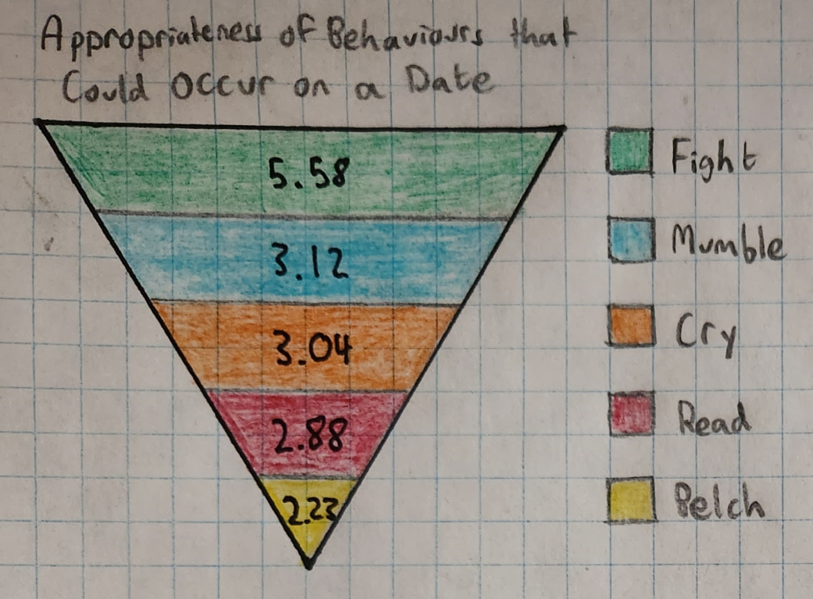**This visualization displays the five most inappropriate behaviours that could occur on a date in the form of an upside-down triangle. The top of the triangle is the largest section, where the *Fight* behaviour is labelled as 5.58. As you get to the smallest part of the visualization you reach the *Belch* behaviour, labelled as 2.23.  
     
   From the data shown in this visualization, we learn that polled individuals rated the *Belch* behaviour as the least appropriate behaviour on a date. While the *Fight* behaviour is rated relatively acceptable compared to the other listed behaviours.  
     
   This visualization uses size to draw a comparison between the appropriateness-value of the listed behaviours, and it uses colour to make each section distinct and easy to compare. While the size is not to scale, it makes the order of appropriateness obvious to the viewer.
2. **Appropriateness of the “Eat” Behaviour in Different Situations:  
   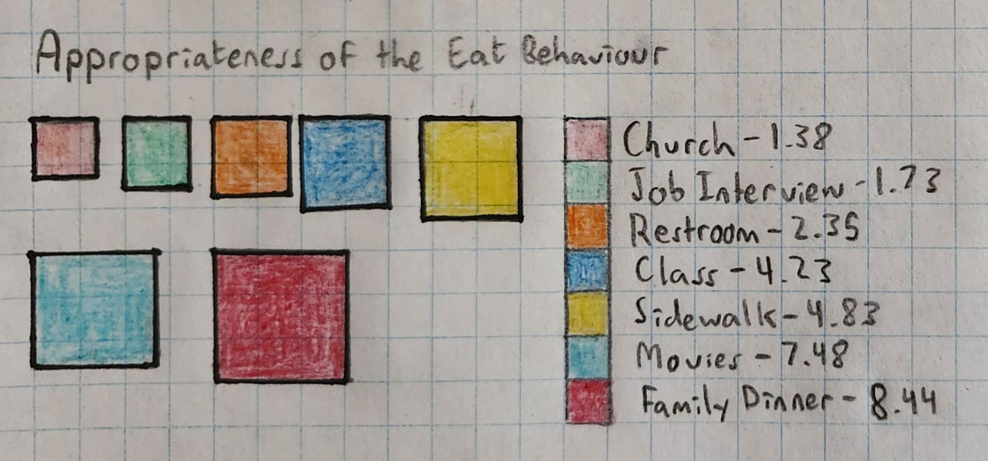**This visualization displays the appropriateness of the *Eat* behaviour in seven different situations. It uses the size of coloured squares to draw obvious comparisons from the viewer, where the area of each square is roughly equivalent to the appropriateness-rating of the given situation.  
     
   The data in the visualization shows us that the *Eat* behaviour is most appropriate during a *Family Dinner* and at the *Movies* and is least appropriate in *Church*, during a *Job Interview*, and in the *Restroom*. These findings intuitively make sense to a viewer, and are clearly shown in the visualization.  
     
   This visualization was selected as it uses relative size to compare the appropriateness-value between the different situations. It uses contrasting colours in the legend to the right to make it clear and easy for a viewer to determine the appropriateness of each coloured square.
3. 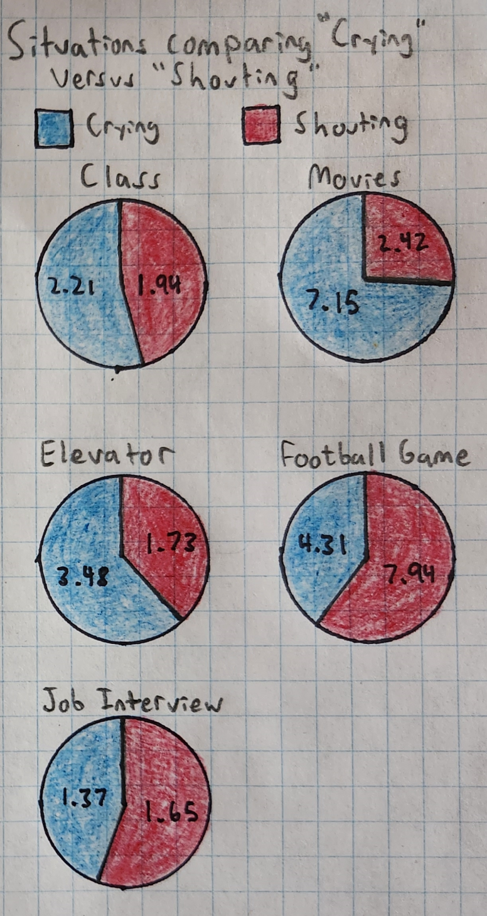**Comparison of “Crying” versus “Shouting”**This visualization compares the appropriateness-value of the *Crying* behaviour to the *Shouting* behaviour in different situations. It uses a series of pie charts to compare *Crying* and *Shouting* for each situation. These pie charts are designed so that viewers can use the relative size between the behaviours to compare their appropriateness.  
     
   Using the data in the visualization, we learn that the *Crying* behaviour is nearly three times the appropriateness of the *Shouting* behaviour while at the *Movies*. At the same time, we learn that the *Shouting* behaviour is roughly 50% more appropriate during a *Football Game* than the *Crying* behaviour.  
     
   This visualization method was selected as pie charts are a good way to compare different situations at a glance.
4. **Five Most Appropriate Behaviours in “Football Game” versus in “Church”  
   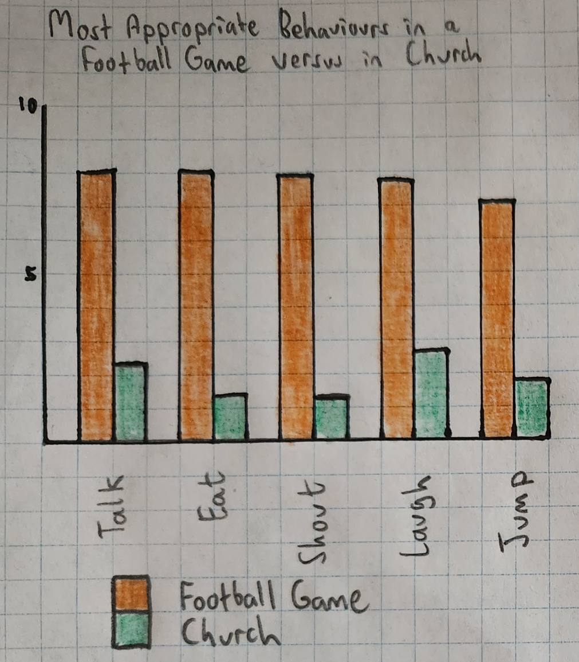**This visualization takes the five most appropriate behaviours in the *Football Game* situation and compares them to the *Church* situation. It uses a double bar chart to easily contrast the different levels of appropriateness between the two situations for the given behaviours.  
     
   From the data provided, we can see that *Talk* is the most appropriate behaviour in a football game with a rating slightly over 8. The appropriateness of this same behaviour in *Church* is considerably lower, only 3.29. In general we learn that all five of the most appropriate behaviours in a *Football Game* situation are not very appropriate in *Church.*This visualization format was selected as the double bar chart makes it straightforward and simple to compare data from multiple situations for the given behaviours.
5. **Appropriateness of the *Write* Behaviour in Different Situations**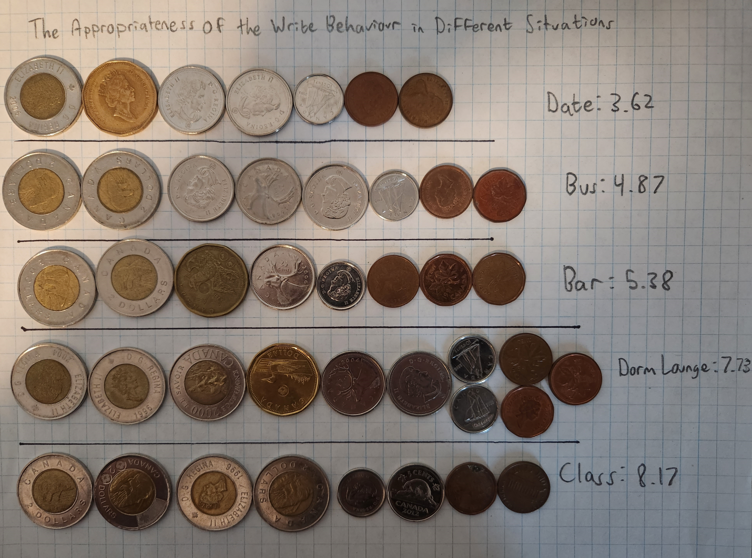This visualization uses Canadian coins to visualize the appropriateness of the *Write* behaviour across different situations. The coins are used as a one-to-one relation between appropriateness-rating and Canadian dollars.  
     
   We can use the data in this visualization to learn that the *Write* behaviour has a wide range of different appropriateness-ratings for different situations, ranging between 3.62 and 8.17 from the data provided.  
     
   This visualization method was chosen as we can quickly compare the different coins without needing to think about it. The *Data* situation immediately looks relatively low as it only contains a single Toonie and a single Loonie, compared to the *Class* situation that consists of 4 Toonies and a small group of other change. The different increments of appropriateness were also selected to give a variety of different combinations of coins.
6. **Bonus: Magic, the Gathering: Modern Metagame Breakdown – 2021**Link to original: <https://www.cardmarket.com/en/Magic/Insight/Articles/Data-Analysis-The-Top-Modern-Decks-Players-End-of-2021>  
     
   **Original Visualization:**  
   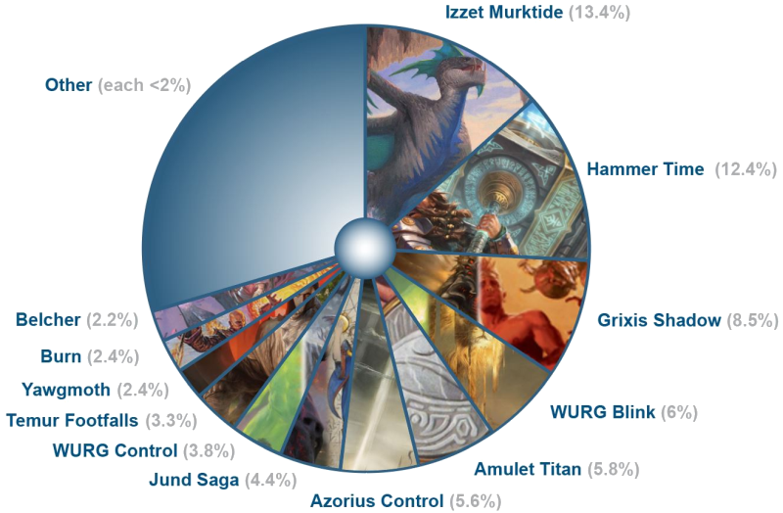 **My Visualization:  
   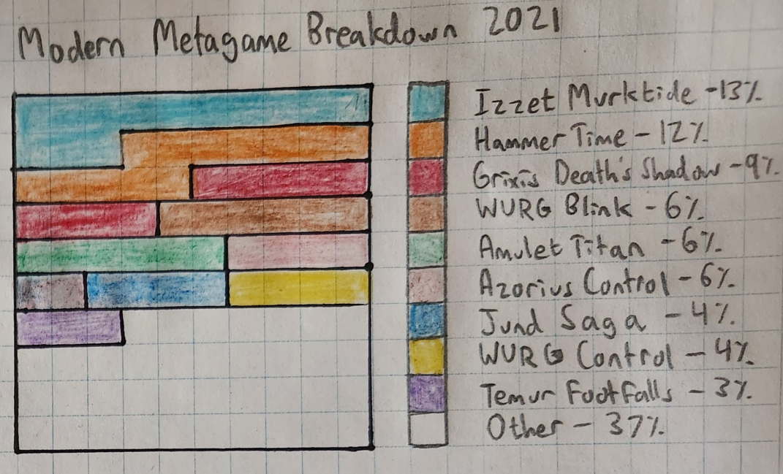**My visualization takes the original pie chart and turns it into a grid of squares, where each square is equal to one percent of the pie chart. A viewer can quickly tell that light-blue section depicting *Izzet Murktide* consists of a larger area than the green section depicting *Amulet Titan*, without needing to compare the percentages directly.